**AN0035**

**Application Notes**

**Rev 1.00 2022/7/29**



**MM32-LINK MINI User Guide**

**Introduction**

The basic functions and the use methods of MM32-LINK MINI emulator are introduced in this paper, as well as the solutions of FAQ.

MM32-LINK MINI basic functions:

* Support MM32 whole series emulating and debugging
* Support CDC virtual serial port
* Support updating and configurating via USB drive

# Basic Functions

The basic functions of MM32-LINK MINI(hereinafter referred to as MINI) are as follows：

|  |  |  |
| --- | --- | --- |
| Functions | Descriptions | Notes |
| MM32-V1 Debug | Programming via SWD port under USB-HID mode. CMSIS debug channel is compliant. | No drivers are required under all Windows systems (Win98 and later versions). |
| CDC virtual serial port | Logging, tracing and terminal emulation. | - |
| MSC updating / configurating | Firmware updating and functional configurations via USB drive. | - |

# Use Methods

## MM32-V1 Debug

### Fundamentals

CMSIS-DAP Protocol is used to realize MM32 Cortex-M whole series MCU emulating and debugging. MM32-V1 Debug uses USB-HID communication mode internal to realize basic emulating and debugging requirements.

### Interface Circuit

MINI debugger has one Micro-USB interface and 10-pin ARM Cortex debugging connector socket. The interface designation of debugging connector and the definition of factory configuration cable are as follows.

|  |  |  |
| --- | --- | --- |
| Pin designation | Factory cable | Descriptions |
| TVCC | ●Red | Power line of target board. Support 3.3V / 5V configuration and 200mA maximum limiting current. |
| Vref | ●Orange | Power feedback line of target board. Vref can be connected to TVCC directly internal and does no need other wires in this condition. |
| GND | ●Black | GND |
| CLK | ●Blue | SWD clock line |
| DIO | ●Yellow | SWD data line |
| Pin designation | Factory cable | Descriptions |
| nRst | ●Gray | Reset line: connected with reset pin on target board. |
| TXD | ●Green | Virtual serial port TX line: connected with RX pin on target board. |
| RXD | ○White | Virtual serial port RX line: connected with TX pin on target board. |
| SWO | ●Purple | Serial port trace output line |

The specific connecting way is shown in Figure 1：

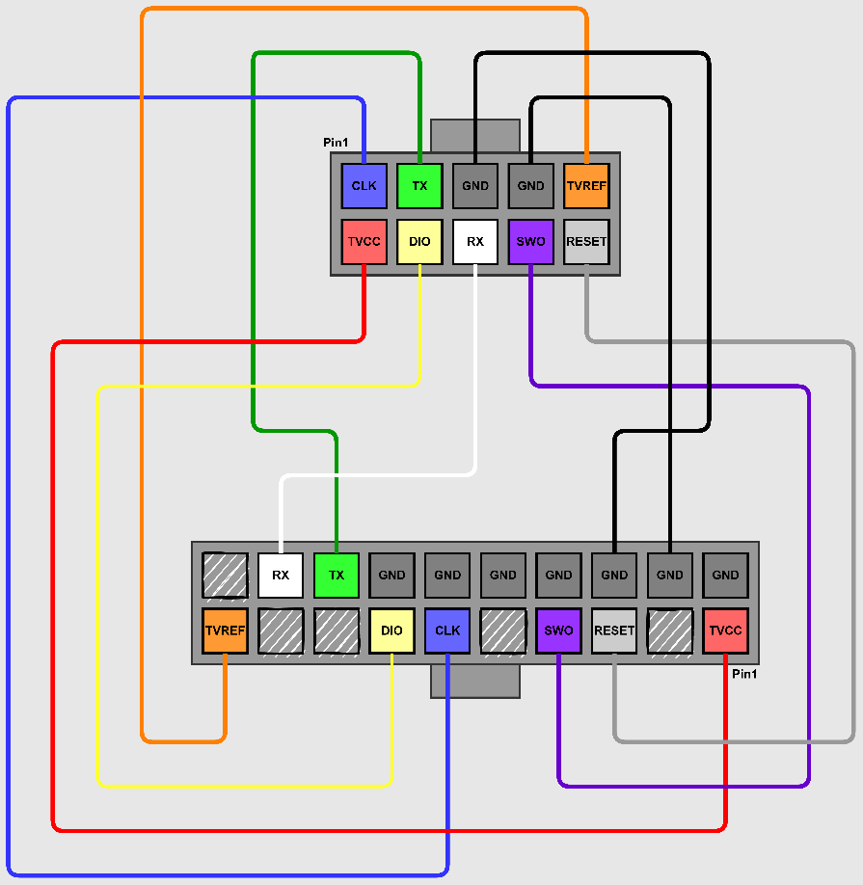

Figure 1 10P-To-20P connections

### Device Serial Number

The device serial number of MM32-LINK Series is encoded in 25 bits. The specific rules are as follows：

|  |  |  |
| --- | --- | --- |
| Member | Bit width | Contents |
| Board ID | Total 3 bit. Bit [0] – Bit [2]. | “059”：MB-059  “088”：MB-088  …… |
| Version | Total 6 bit. Bit [3] – Bit [8]. | Ver “YYMMDD” |
| Chip UID | Total 16 bit. Bit [9] – Bit [24]. | MCU-UUID 64 bit |

### Tutorial

#### Keil

① Open the *Options for Target – Debug* dialog to choose driver.

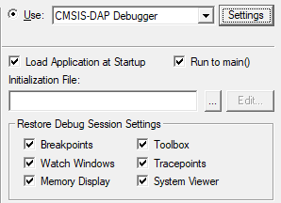

Enable Use and select CMSIS-DAP Debugger in pull-down list.

② Click Settings button and configure debugging option.

*Cortex-M Target Driver Setup* dialog pop out, consisting of three sets of information and configurations which are shown in table below：

**CMSIS-DAP JTAG/SW Adapter**

|  |  |  |
| --- | --- | --- |
| Info. | Descriptions | Notes |
| Serial No | Display the identifier of the debugger adapter in use. When more adapters are connected, use the drop-down list to specify the adapter or driver. | MM32-LINK Series specifications: Board[3] + Version[6] + UUID[16] |
| Firmware Version | Display the firmware version detected on the device. | - |
| SWJ | Enable the driver to switch between JTAG and SW mode. | Enable (Recommended) |
| Port | Set the internal debugging interface: SW or JTAG. | SW default in MM32 whole series. |
| Max Clock | Set the debugging clock rate for communicating to the target board. | Suggest 5MHz maximum. Update later. |

Choose MM32_V1 CMSIS-DAP adapter in use. Dialog is shown in figure below：

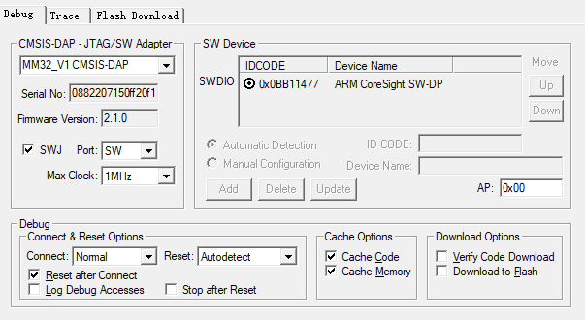

**SW Device**

SW Device shows one or more debug targets connected through the Serial Wire interface. The IDCODE and Device Name are displayed automatically for each device.

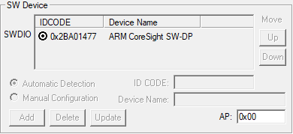

**Debug**

The Debug section provides controls for connecting and resetting the device, and caching and downloading the code. The settings are applied each time a debugging session is started.

* + - Connect & Reset Options

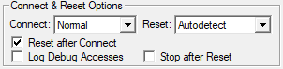

Choose Normal as connecting way and Autodetect as reset way.

* + - Cache Options

By default, caching options are enabled to get maximum performance.

* + - Download Options

Download Options control the downloading of code to the target system when starting a debugging session. Enable Verify Code Download option by default to ensure program correlation between the image loaded in target system and the image loaded in the µVision debugger. Download to Flash option is disabled by default. Users could set these options according to the project debugging requirements.

#### IAR

① Open the *Project - Options – Debugger* dialog to select driver.

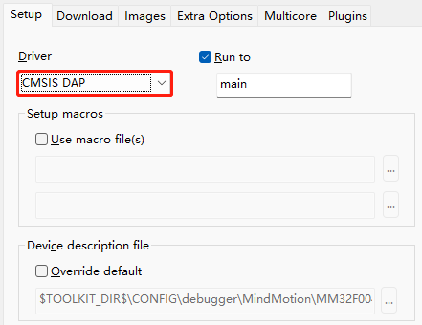

Select CMSIS DAP in pull-down list.

② Click CMSIS DAP on the left and set debugging options.

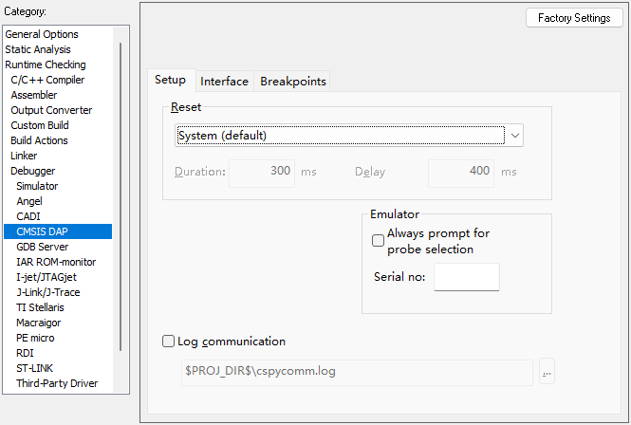

* + - **Setup**

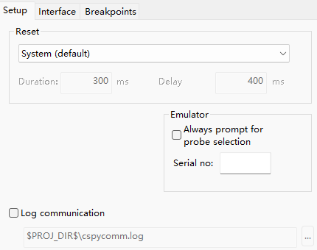

Select System (default) as reset strategy. Switch to another reset strategy if download and debugging is abnormal due to the different target chip environments.

* + - **Interface**

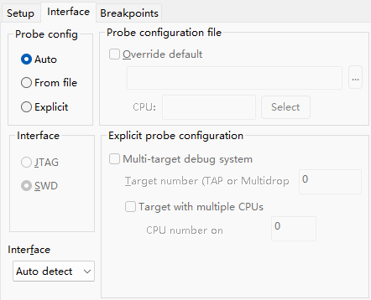

Ensure SWD mode is selected and Auto Detect could be selected as maximum interface rate。

## CDC Virtual Serial Port

Bi-direction communication can be realized between MINI debugger serial port and target microcontroller. Support baud rate of 9600 / 14400 / 19200 / 28800 / 38400 / 56000 / 57600 / 115200 and more settings are supported as well.

Notes: Pay attention to the TX / RX interface line sequence when connecting MINI virtual serial port and target chip port.

## USB Drive Updating / Configurating

* + - Firmware updating

By default, MM32LINK-Series latest firmware has been burned into MINI in factory. Users can update firmware as required. Specific operations are as follows:

① Normal mode：

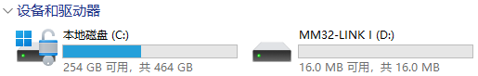

First, create a blank file named “start_bl.act”; After ensuring the emulator is in idle mode, save the file under “MM32-LINK *” USB drive content by sending or dragging.

Note：Identifier of MM32LINK Series USB drive

|  |  |  |
| --- | --- | --- |
| Identifier | Type | Notes |
| MM32-LINK A | MM32-LINK MAX |  |
| MM32-LINK I | MM32-LINK MINI |  |

② Maintenance mode:

After MINI has been read and reset, “Bootloader” portable disk is displayed on PC interface.

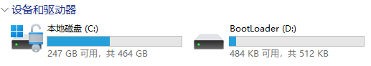

③ Drag to update firmware

Drag “mm32link_mini_xxxx.hex” firmware file to USB drive. Emulator will exit maintenance mode automatically after updating is done.

* + - 3.3V / 5V configuration

5V output enable: First, create a blank file named “five_on.cfg”; After ensuring the emulator is in idle mode, save the file under “MM32-LINK *” USB drive content by sending or dragging.

5V output disable(default): File name is “five_off.cfg” and other configuration methods are the same.

Power configurations take effect immediately.

* + - Beep configuration

Beep enable(default): First, create a blank file named “beep_on.cfg”; After ensuring the emulator is in idle mode, save the file under “MM32-LINK *” USB drive content by sending or dragging.

Beep disable: File name is “beep_off.cfg” and other configuration methods are the same.

Beep configurations take effect after power on reset.

# FAQ

## Power supply related

Q: What should user pay attention to when connecting target board feedback line Vref and target power output line TVCC?

A: If MINI emulator connects 2.0mm pin directly, which means Vref and TVCC are short connected, 10P Vref voltage is 5V that TVCC is configured with. Pay attention to whether the target board itself has been influenced by the Vref 5V power supply domain on the target board. Ignore this attention note if having step-down and voltage regulator circuit.

## IDE related

Q: How to solve the error in download process if CMSIS DAP debugging has been selected in IAR and USB / debugging cable has been correctly connected?

A: 1 Check interface mode is SWD and reduce SWD communication rate.

2 Switch to suitable reset way: System (Recommended) / Hardware / Software;

3 If error message “Failed to connect to CPU Session Aborted” or “Error while calling macro execUserFlashExit” continues, the emulator interface needs to be reinserted. By default, nRst pin outputs a serial of reset pulse to target chip after power on.

4 If the problem still could not be solved, erasing Flash can be taken into consideration.

# Revision history

Table 4‑1 Document revision history

|  |  |  |
| --- | --- | --- |
| Date | Revision | Changes |
| 2022/7/29 | 1.00 | Initial release |